**I. Pen-and-paper**

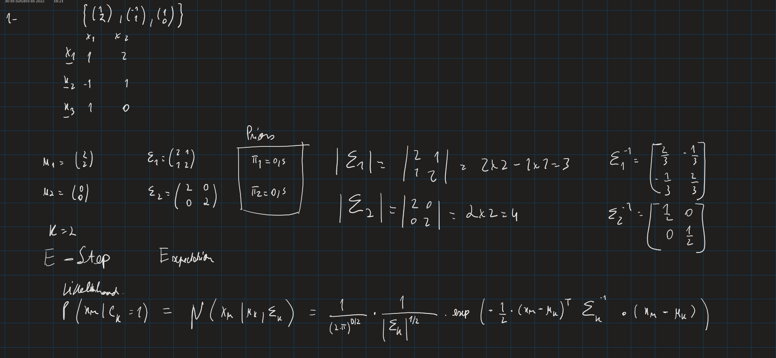

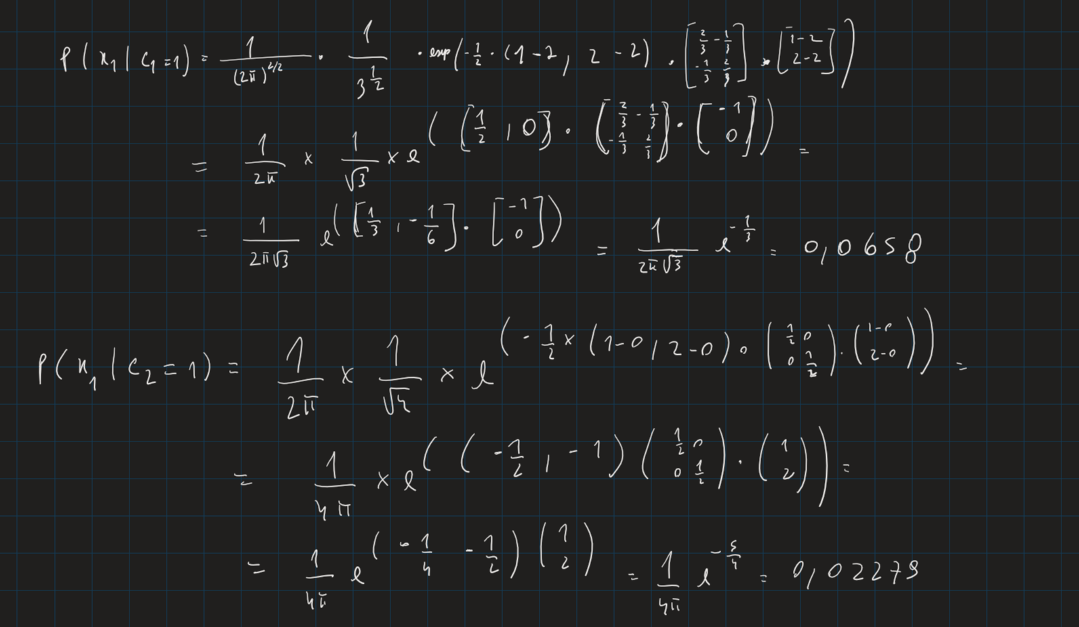

­­­­­­

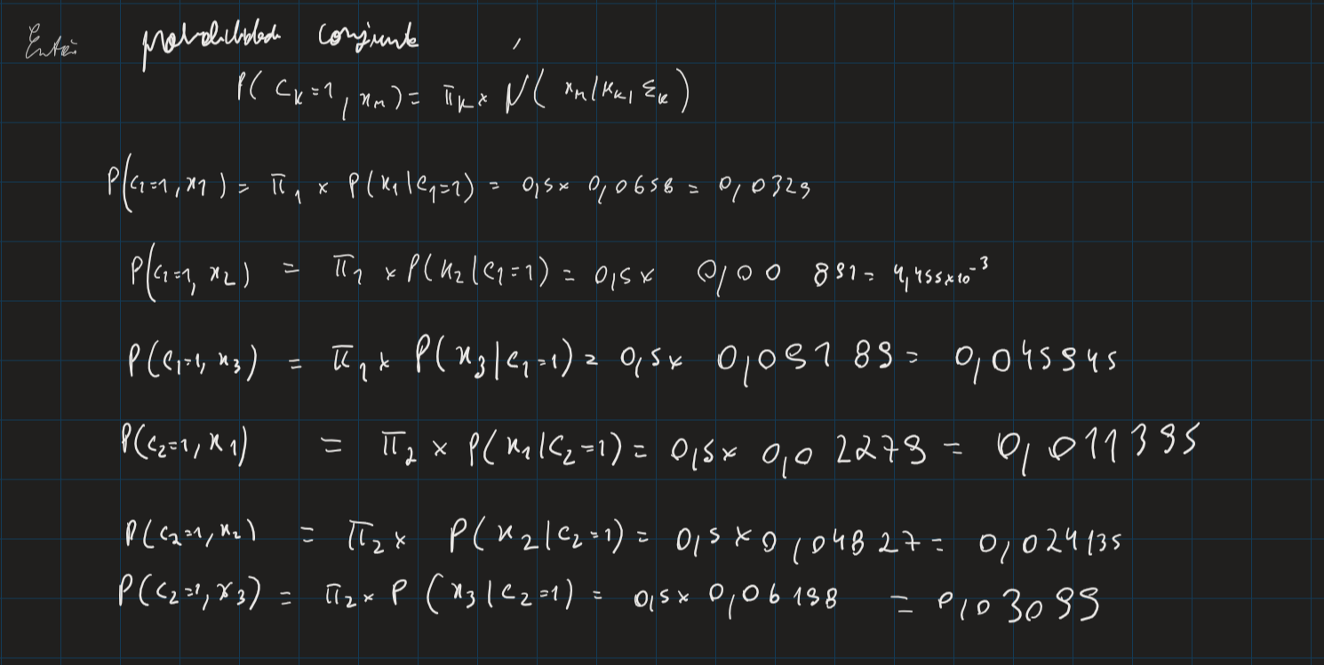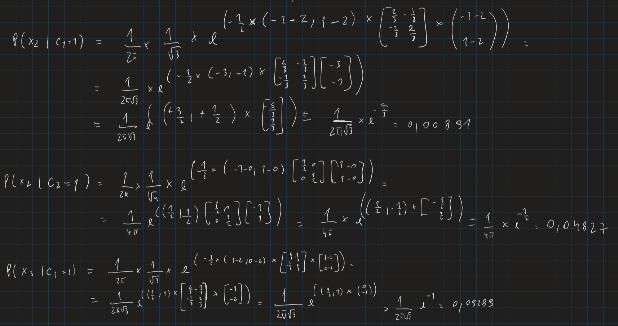

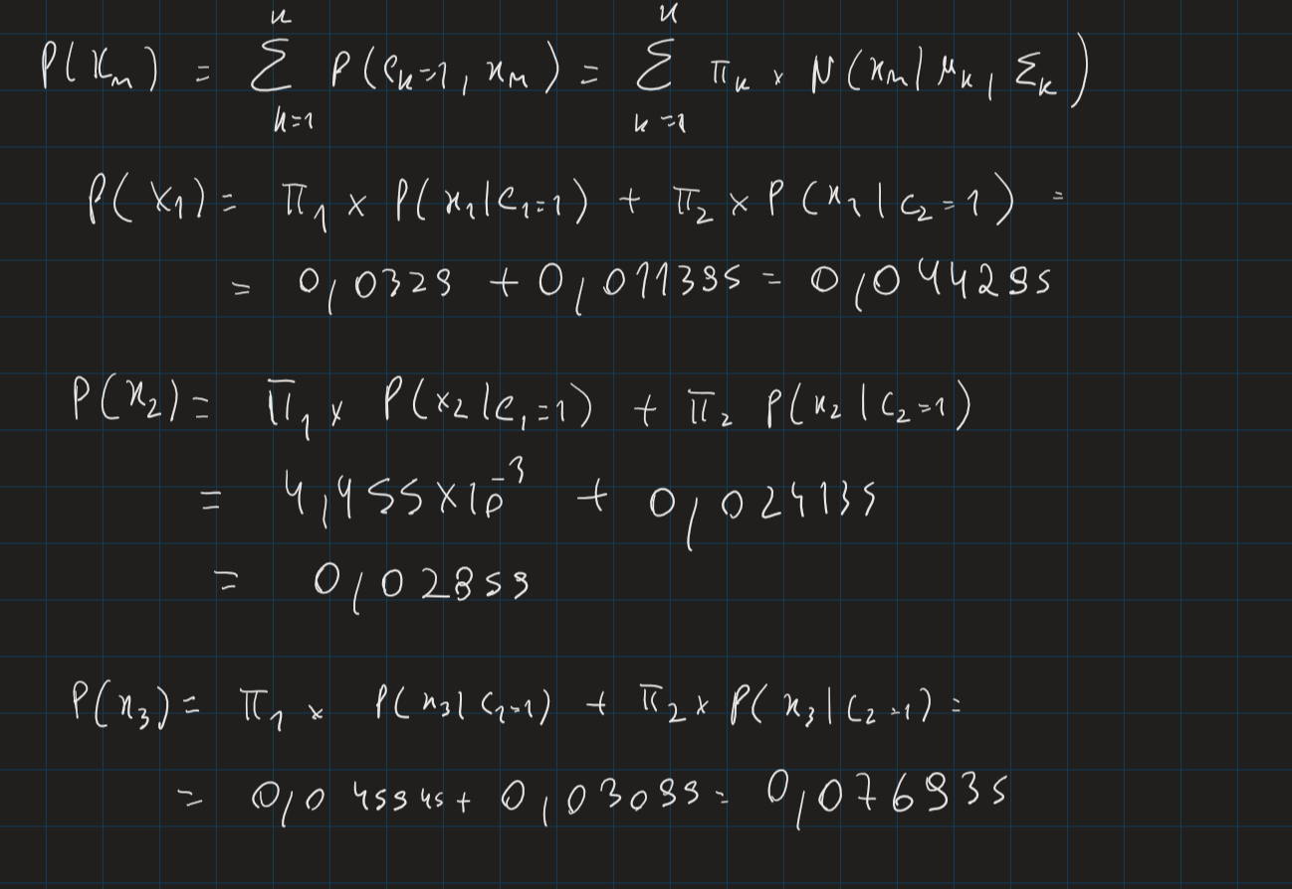

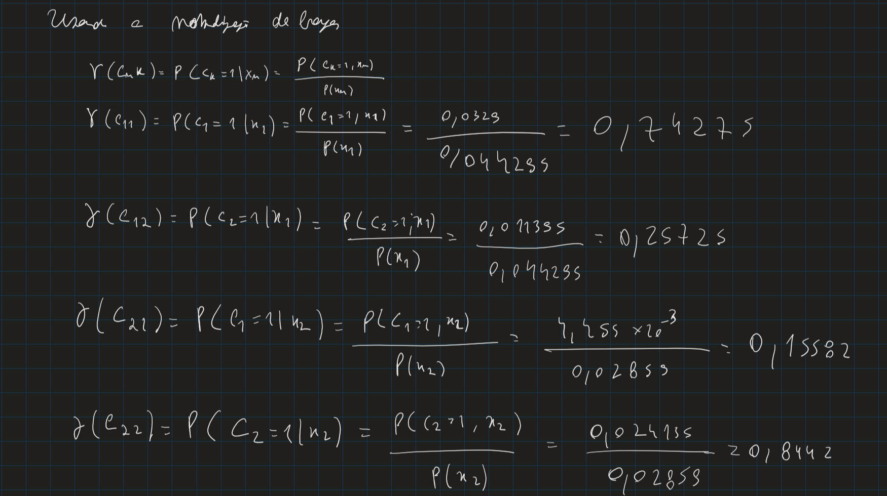

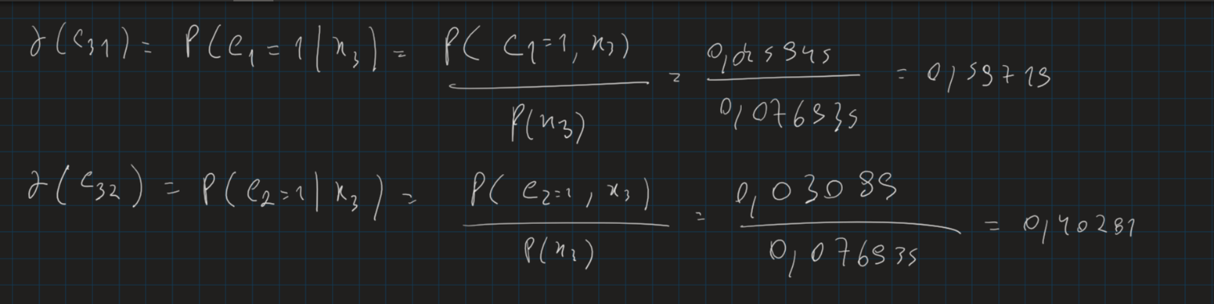

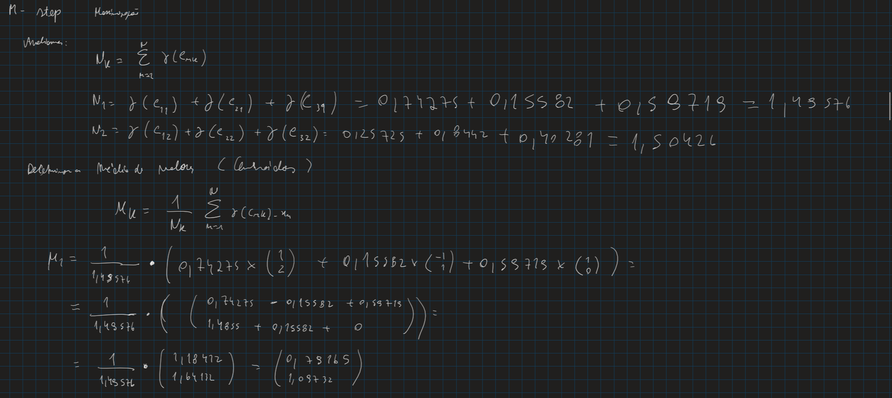

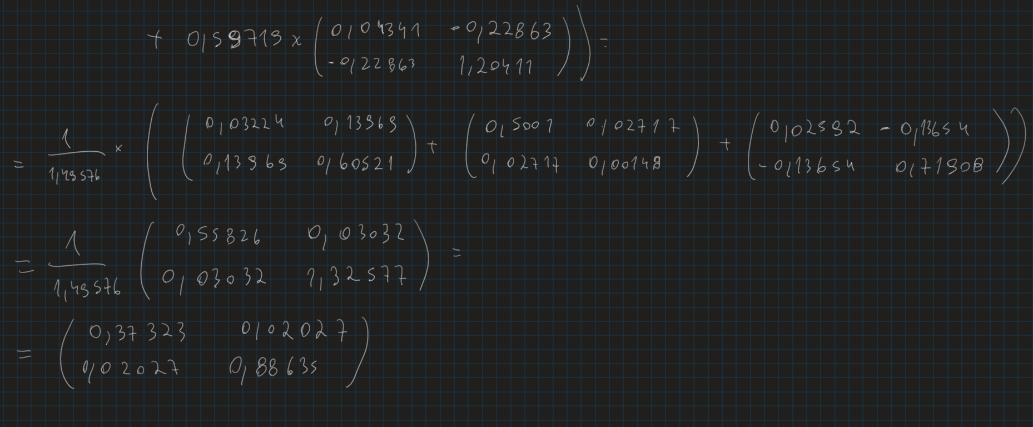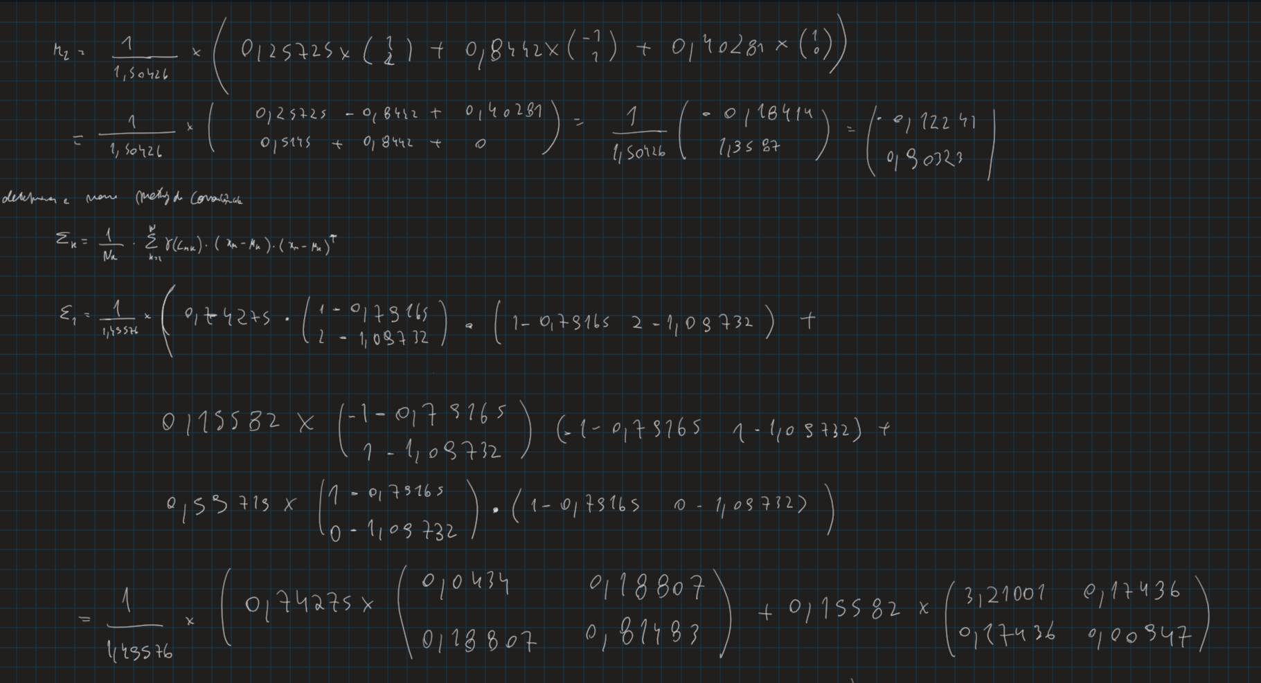

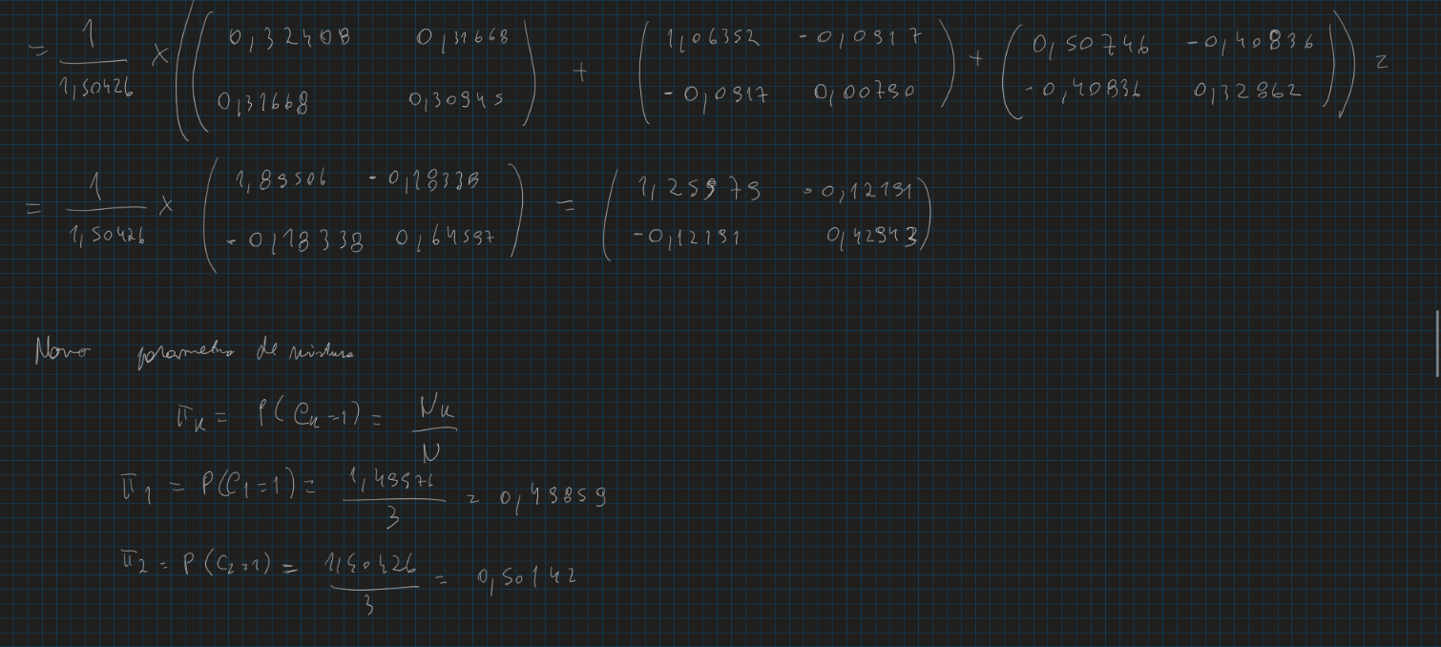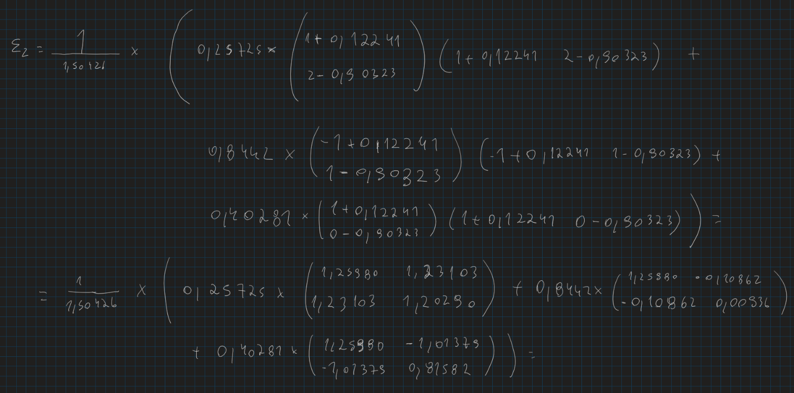

1. 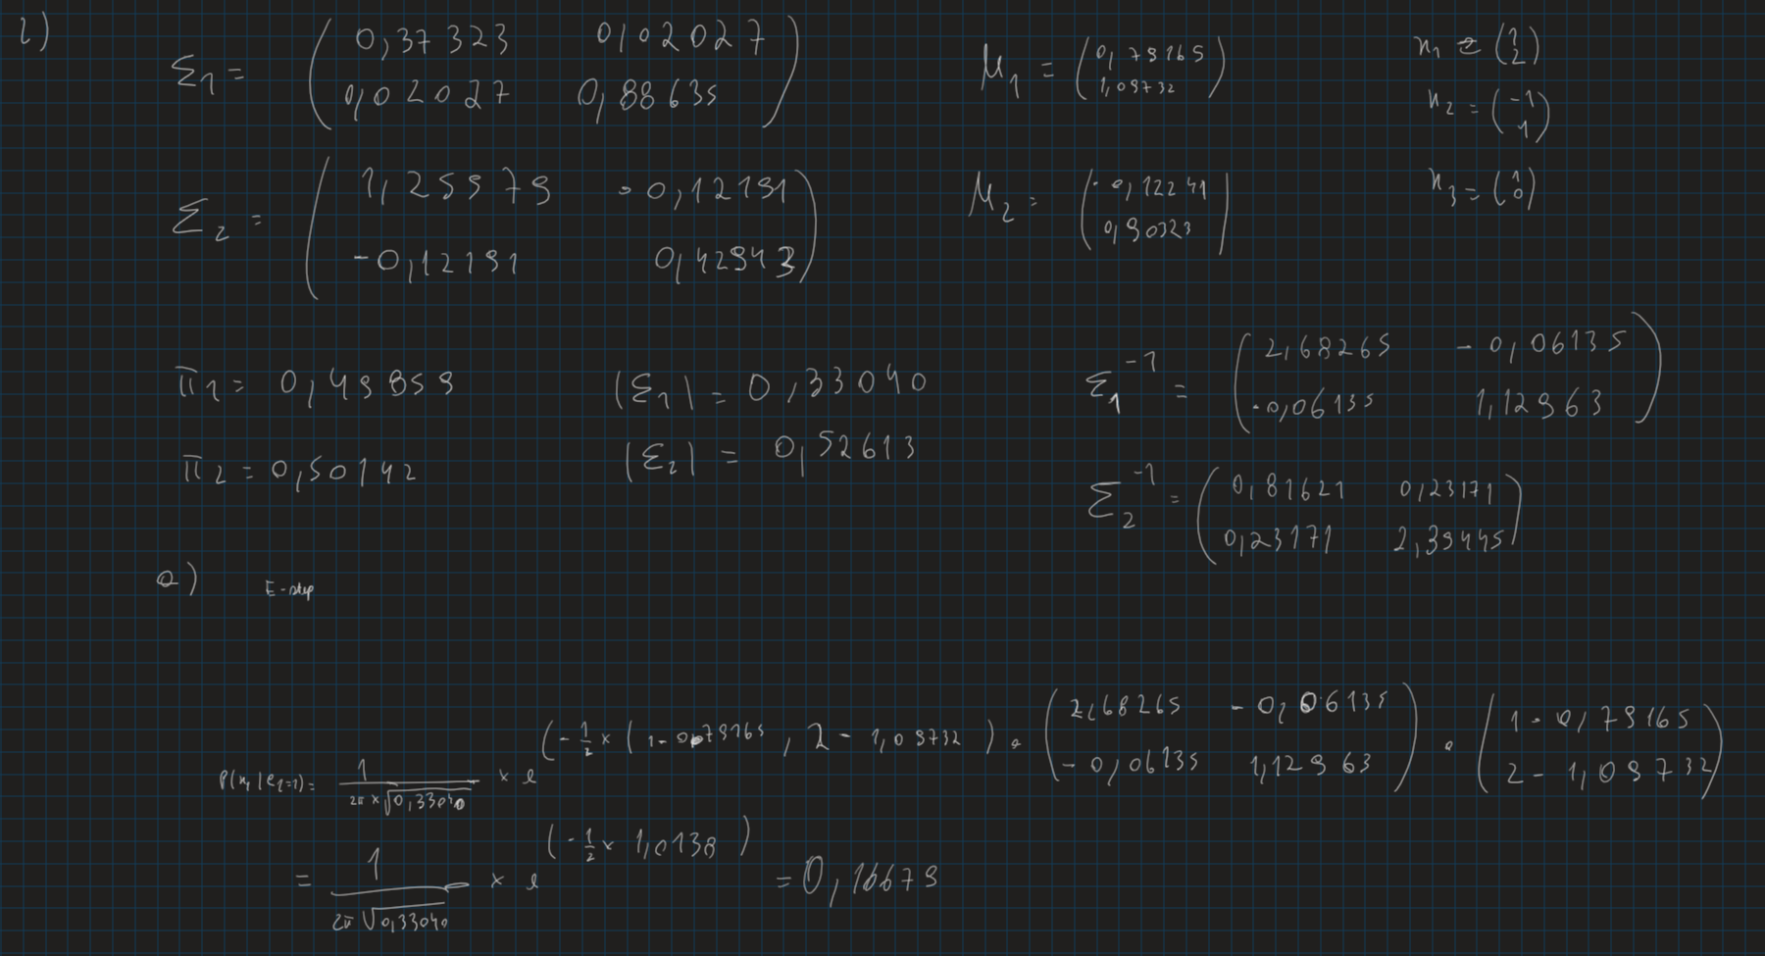A)

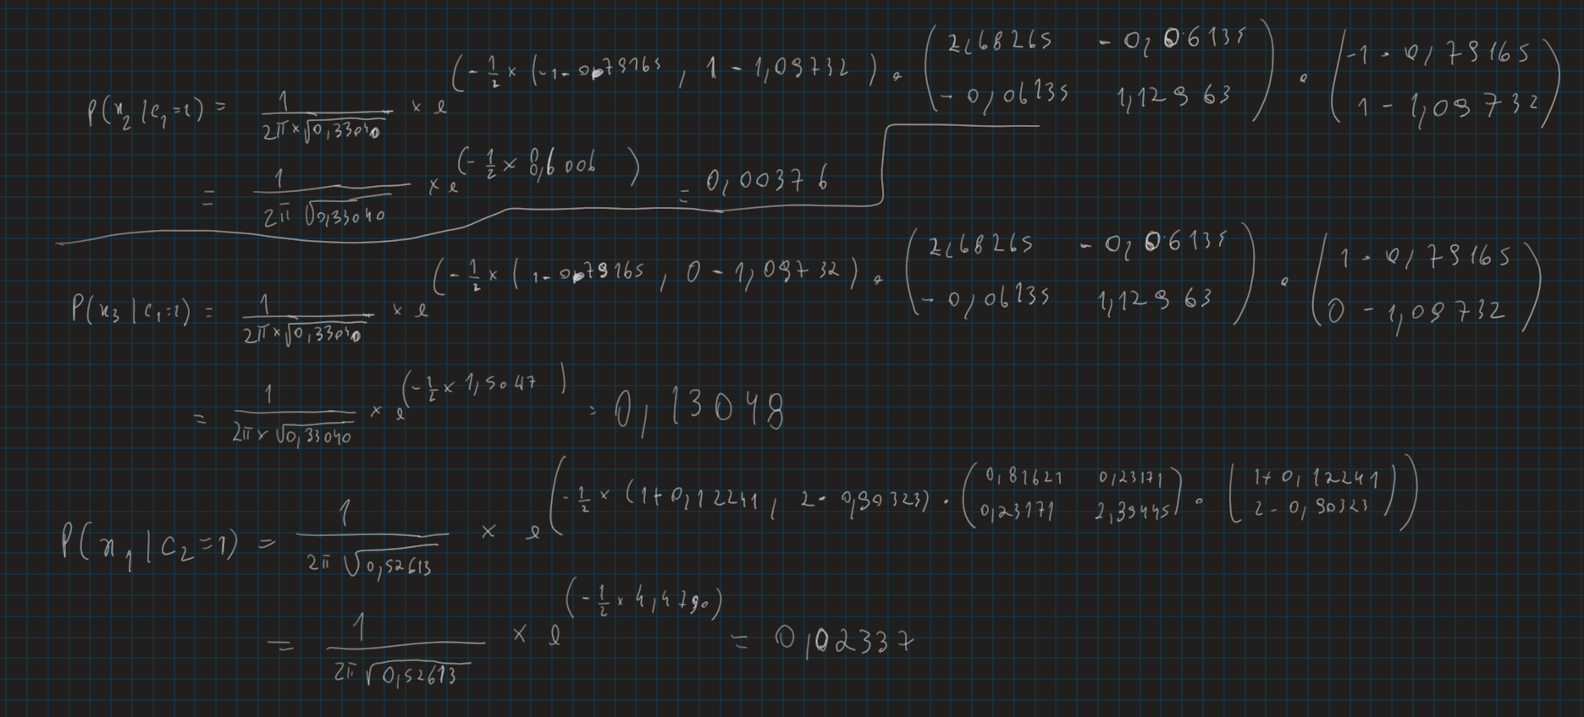

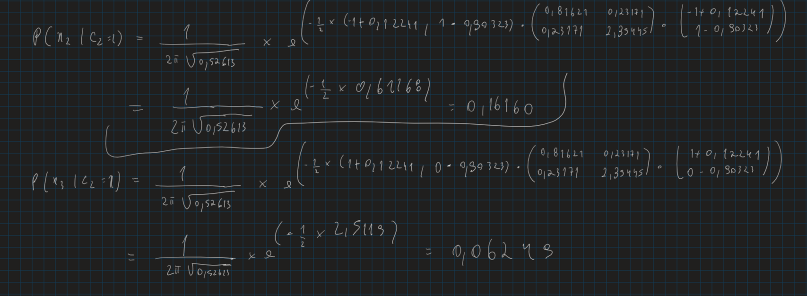

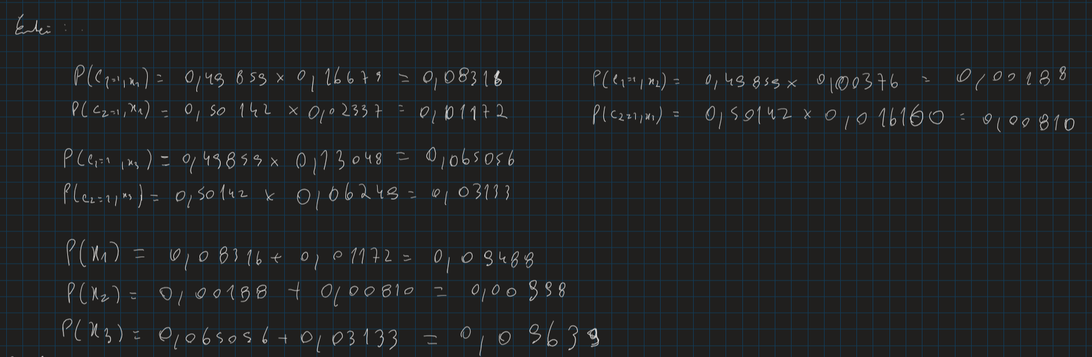

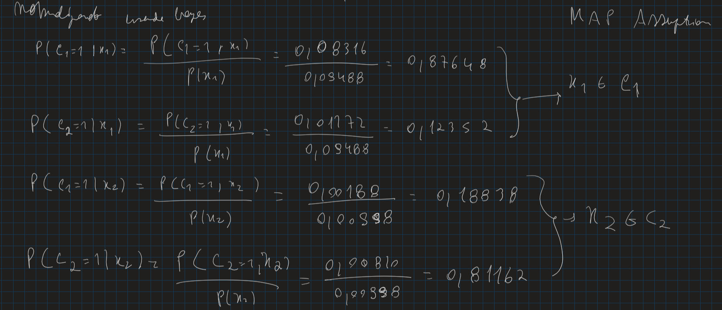

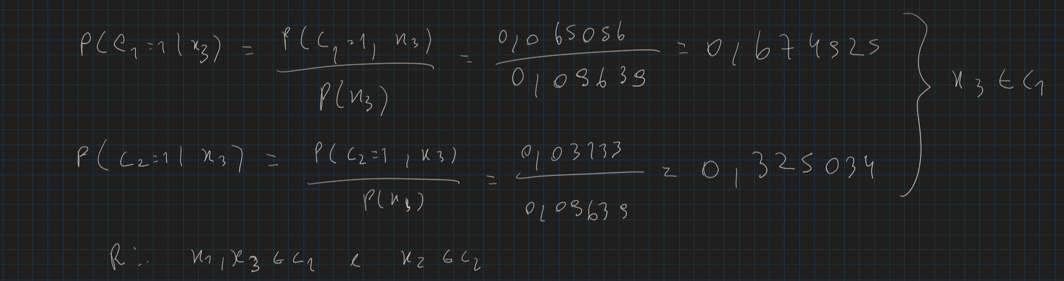

b)

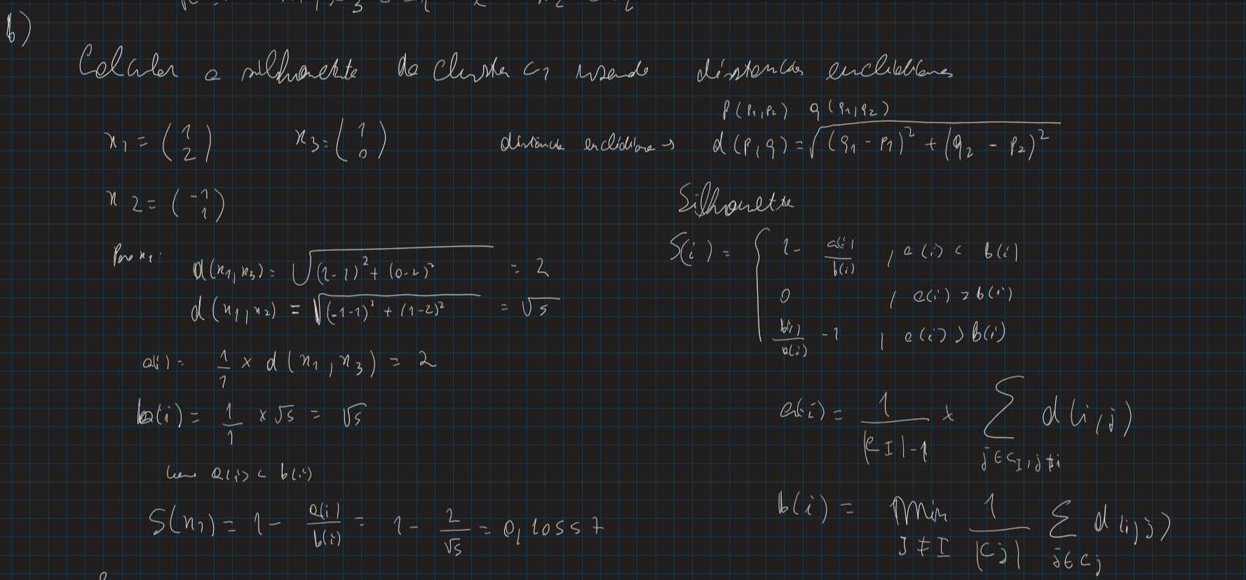

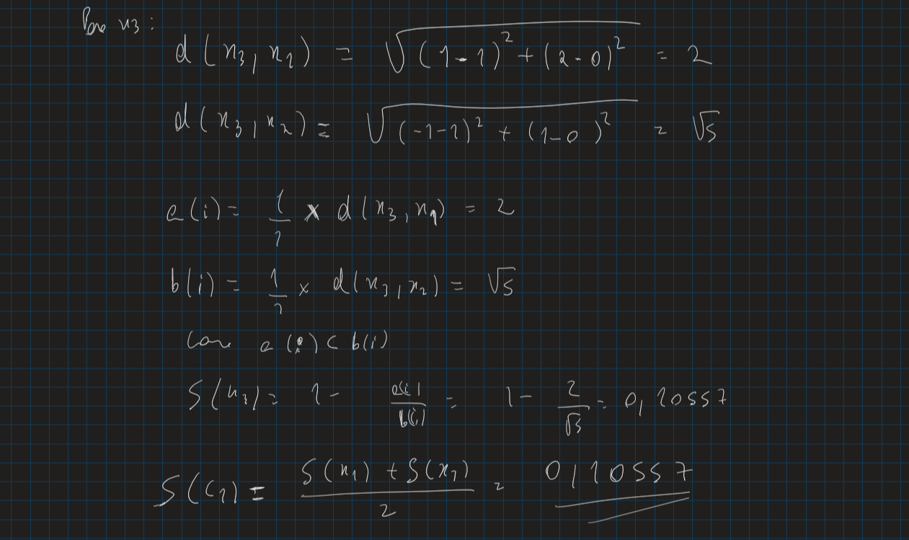



**II. Programming and critical analysis**

**1)**

[0] Silhouette (euclidian): 0.1136202757517943

[1] Silhouette (euclidian): 0.11403554201377072

[2] Silhouette (euclidian): 0.1136202757517943

[0] Purity: 0.7671957671957672

[1] Purity: 0.7632275132275133

[2] Purity: 0.7671957671957672

**2)**

O que está a causar o não determinismo é facto de estarmos inicialmente a considerar que os centroides das respetivas três clusters são completamente aleatórios e usando a distancia da euclidiana dos pontos a esses centroides associamos os pontos aos clusters dos respetivos centroides e caso o centroide altere quando os pontos estão associados aos seus respetivos clusters,  então voltamos a recalcular os centroides até que o calculo do novo centroide resulte nos centroides usados no calculo dos mesmos.

**3)**

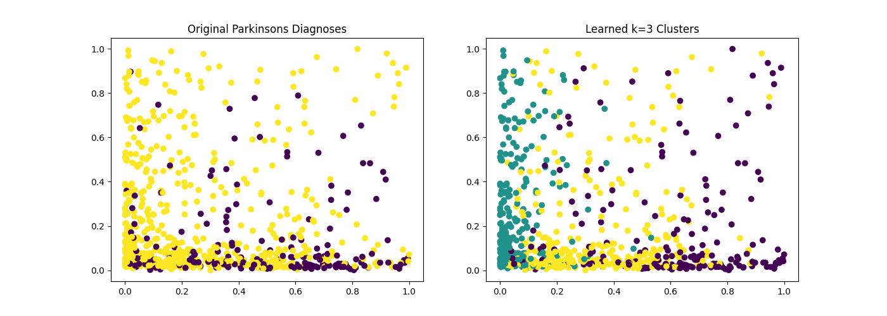

**4)**

**É necessário 31 componentes principais para explicar mais de 80% de variabilidade**

**III. APPENDIX**

import fractions

import pandas as pd

import numpy as np

#*####################################################################################

#* 1)

#*####################################################################################

#* import data

from scipy.io.arff import loadarff

data = loadarff("pd_speech.arff")

df = pd.DataFrame(data[0])

df['class'] = df['class'].str.decode('utf-8')

df['class'] = pd.to_numeric(df["class"])

#* aux variable

num_columns = df.shape[1]

#* pre-process data

from sklearn.preprocessing import MinMaxScaler

df_scaled = df.copy()

df_scaled.iloc[:, 0:num_columns-1] = MinMaxScaler().fit_transform(df.iloc[:, 0:num_columns-1])

#* partition data

X, y = df_scaled.iloc[:, 0:num_columns-1], df_scaled["class"]

#* parameterize clustering

from sklearn import cluster

kmeans_algo_0 = cluster.KMeans(n_clusters=3, random_state=0)

kmeans_algo_1 = cluster.KMeans(n_clusters=3, random_state=1)

kmeans_algo_2 = cluster.KMeans(n_clusters=3, random_state=2)

#* learn the model

kmeans_model_0 = kmeans_algo_0.fit(X)

kmeans_model_1 = kmeans_algo_1.fit(X)

kmeans_model_2 = kmeans_algo_2.fit(X)

#* produced clusters

y_pred_0 = kmeans_model_0.labels_

y_pred_1 = kmeans_model_1.labels_

y_pred_2 = kmeans_model_2.labels_

#* compute Silhouette

from sklearn import metrics

print("[0] Silhouette (euclidian):", metrics.silhouette_score(X, y_pred_0, metric='euclidean'))

print("[1] Silhouette (euclidian):", metrics.silhouette_score(X, y_pred_1, metric='euclidean'))

print("[2] Silhouette (euclidian):", metrics.silhouette_score(X, y_pred_2, metric='euclidean'))

#/ compute Purity

import numpy as np

def purity_score(y_true, y_pred):

#/compute contingency/confusion matrix

    confusion_matrix = metrics.cluster.contingency_matrix(y_true, y_pred)

    return np.sum(np.amax(confusion_matrix, axis=0)) / np.sum(confusion_matrix)

y_true = y

print("[0] Purity:", purity_score(y_true, y_pred_0))

print("[1] Purity:", purity_score(y_true, y_pred_1))

print("[2] Purity:", purity_score(y_true, y_pred_2),"\n")

#*###################################################################################

#* 3)

#*####################################################################################

#* compute features' variances

from sklearn.feature_selection import VarianceThreshold

selection = VarianceThreshold().fit(X)

#* get second max variance

import heapq

max_three_variances = heapq.nlargest(3, selection.variances_)

third_max_variance = max_three_variances[2]

#* feature selection

X_new = VarianceThreshold(threshold=third_max_variance).fit_transform(X)

#* plot

import matplotlib.pyplot as plt

plt.figure(figsize=(14, 5))

plt.subplot(121)

plt.title(label="Original Parkinsons Diagnoses")

plt.scatter(X_new[:,0], X_new[:,1], c=y)

plt.subplot(122)

plt.title(label="Learned k=3 Clusters")

plt.scatter(X_new[:,0], X_new[:,1], c=y_pred_0)

plt.savefig("figures/plot.png")

plt.show()

#*####################################################################################

#* 4)

#*####################################################################################

#* learn the transformation (components as linear combination of features)

from sklearn.decomposition import PCA

pca = PCA(n_components=X.shape[1])

pca.fit(X)

variability = 0

number_of_principal_components = 1

for f in pca.explained_variance_ratio_:

    variability += f

    if variability > 0.80:

        break

    number_of_principal_components += 1

print(number_of_principal_components)

**END**